Regular-base Pyramid

Definition
# Source: AI Source: Provided by: [Data Path: Persons Table -> ID Column: 1, Name_En Column: Motasem Essam] -> From: [ChatGPT] on [7/25/2026]
A regular-base pyramid is a three-dimensional geometric solid whose base is a regular polygon, meaning that all its sides and all its interior angles are equal.
In the conventional classification of pyramids, a regular-base pyramid is typically presented as a regular pyramid when its apex is positioned directly above the center of the base. In this case, its lateral faces are congruent isosceles triangles.
The base may be an equilateral triangle, square, regular pentagon, regular hexagon, or any other regular polygon with three or more sides.
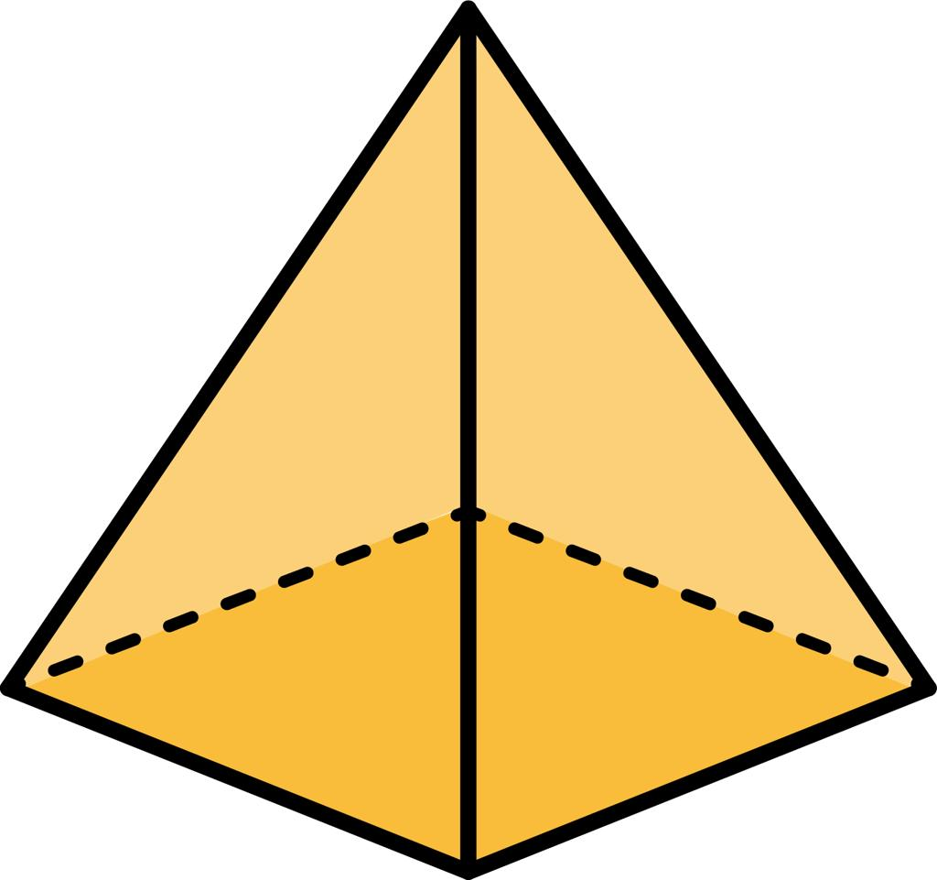
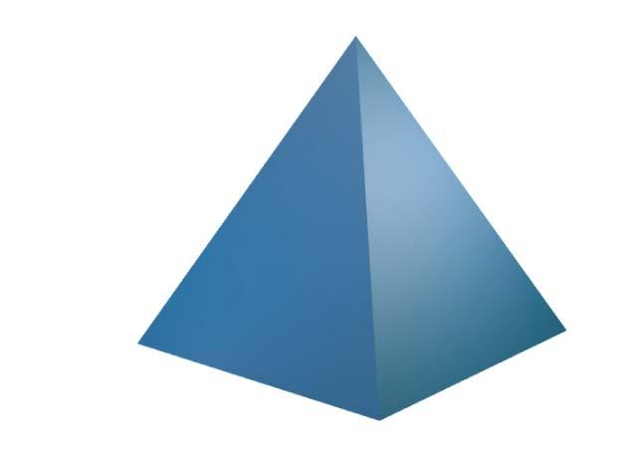
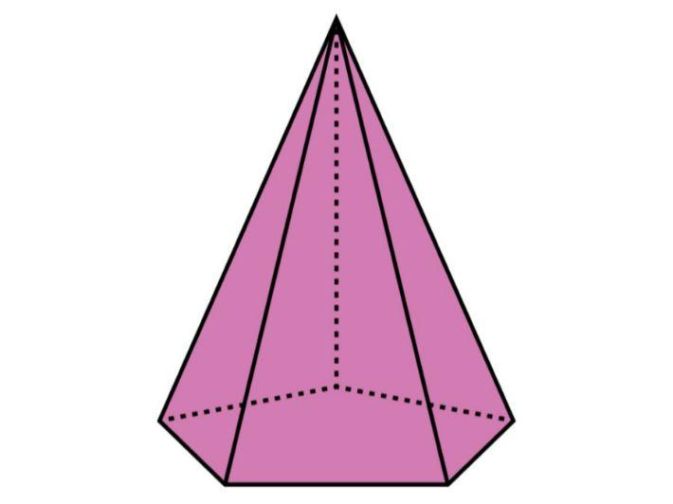

Simple Definition
# Source: AI Source: Provided by: [Data Path: Persons Table -> ID Column: 1, Name_En Column: Motasem Essam] -> From: [ChatGPT] on [7/25/2026]
A regular-base pyramid is a pyramid with a base that has equal sides and equal angles.
For example, a pyramid with a square base has a regular base because all four sides of the square are equal and all four interior angles are ${90}^{∘}$.

Classification Tree
# Source: AI Source: Provided by: [Data Path: Persons Table -> ID Column: 1, Name_En Column: Motasem Essam] -> From: [ChatGPT] on [7/25/2026]
Pyramids by Base Regularity
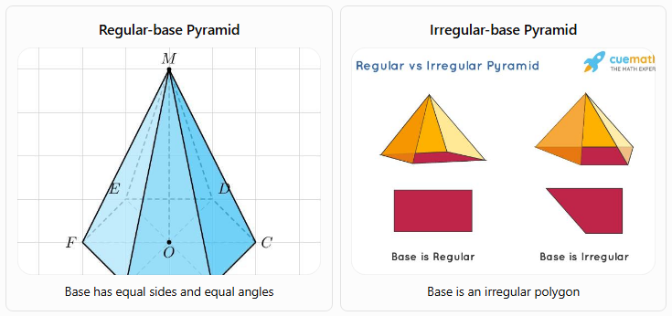
Regular-base Pyramid
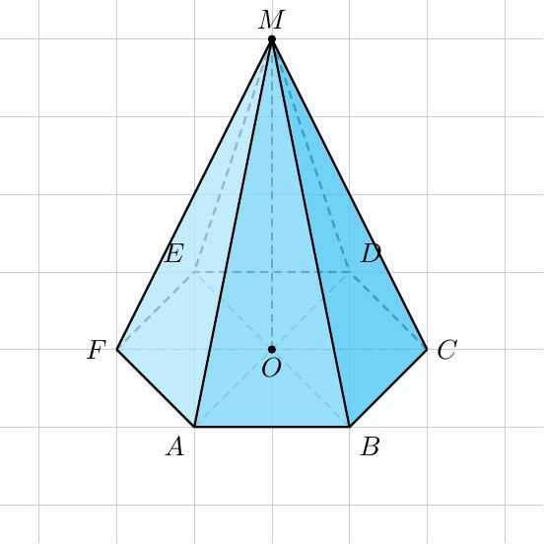
Base has equal sides and equal angles
Irregular-base Pyramid
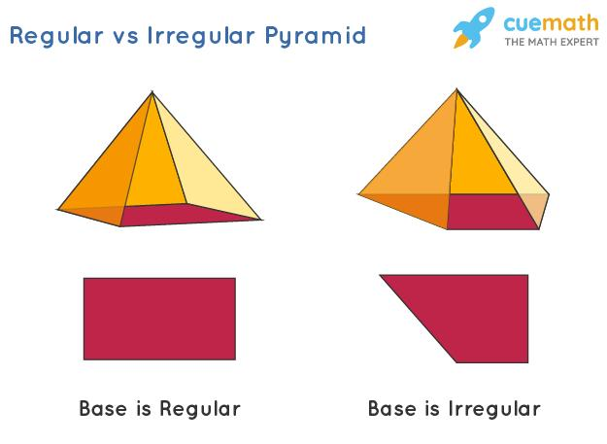
Base is an irregular polygon
A. By Number of Base Sides
A regular-base pyramid can be classified by the number of sides in its base.
- Regular triangular pyramid: Has an equilateral triangle as its base.
- Regular quadrilateral pyramid: Has a square as its base.
- Regular pentagonal pyramid: Has a regular pentagon as its base.
- Regular hexagonal pyramid: Has a regular hexagon as its base.
- Regular \(n\)-gonal pyramid: Has a regular polygon with \(n\) sides as its base.
B. By Spatial Orientation
- Right pyramid with a regular base: The apex lies directly above the center of the regular polygon. The lateral faces are congruent isosceles triangles.
- Oblique pyramid with a regular base: The apex is offset from the base center. The base remains regular, but the lateral faces are generally not congruent.
Terminology note: Some textbooks use regular pyramid specifically for a pyramid with both a regular polygonal base and an apex directly above the base center. Under that stricter definition, an oblique pyramid with a regular base is not called a regular pyramid.

Key Characteristics
# Source: AI Source: Provided by: [Data Path: Persons Table -> ID Column: 1, Name_En Column: Motasem Essam] -> From: [ChatGPT] on [7/25/2026]
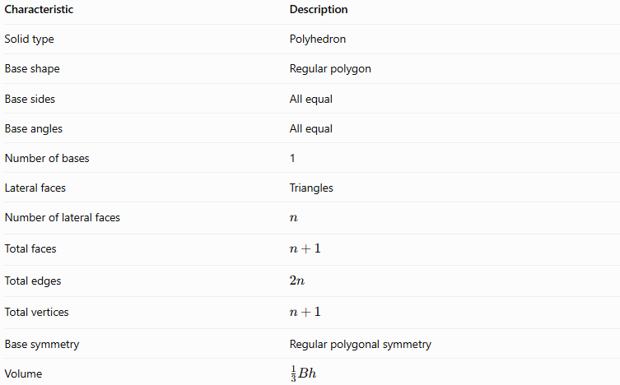
Characteristic | Description
Solid type | Polyhedron
Base shape | Regular polygon
Base sides | All equal
Base angles | All equal
Number of bases | 1
Lateral faces | Triangles
Number of lateral faces | $$n$$
Total faces | $$n+1$$
Total edges | $$2n$$
Total vertices | $$n+1$$
Base symmetry | Regular polygonal symmetry
Volume | $$\frac{1}{3}Bh$$
Here, $n$ represents the number of sides of the base polygon.

Geometric Representation
# Source: AI Source: Provided by: [Data Path: Persons Table -> ID Column: 1, Name_En Column: Motasem Essam] -> From: [ChatGPT] on [7/25/2026]
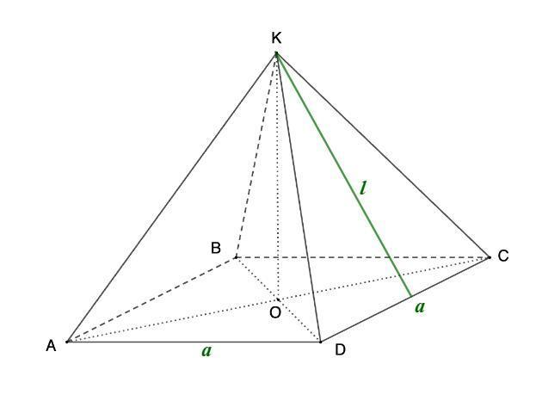
Consider a regular square-based pyramid with apex $S$, square base $ABCD$, and base center $O$.
Its main components are:
- Base $ABCD$: A square with four equal sides and four equal interior angles.
- Apex $S$: The top vertex of the pyramid.
- Base edges: $AB,BC,CD,$ and $DA$.
- Lateral edges: $SA,SB,SC,$ and $SD$.
- Lateral faces: Four congruent isosceles triangles.
- Height $h$: The perpendicular distance from the apex to the base plane.
- Slant height $l$: The perpendicular distance from the apex to the midpoint of a base edge, measured along a lateral face.
- Base apothem $r$: The distance from the base center to the midpoint of a base edge.

Mathematical Representations and Formulas
# Source: AI Source: Provided by: [Data Path: Persons Table -> ID Column: 1, Name_En Column: Motasem Essam] -> From: [ChatGPT] on [7/25/2026]
Let:
- $n$ = number of sides of the regular base
- $a$ = base side length
- $B$ = base area
- $p$ = base perimeter
- $h$ = perpendicular height
- $l$ = face slant height
- $r$ = base apothem

A. Base perimeter
# Source: AI Source: Provided by: [Data Path: Persons Table -> ID Column: 1, Name_En Column: Motasem Essam] -> From: [ChatGPT] on [7/25/2026]
Because all base sides are equal:
$$\boxed{p=na}$$

B. Base area
# Source: AI Source: Provided by: [Data Path: Persons Table -> ID Column: 1, Name_En Column: Motasem Essam] -> From: [ChatGPT] on [7/25/2026]
For a regular $n$-sided polygon:
$$\boxed{B=\frac{1}{2}pr}$$
Substituting $p=na$:
$$\boxed{B=\frac{1}{2}nar}$$
The base area can also be calculated directly from the side length:
$$\boxed{B=\frac{na^{2}}{4\tan\left(π/n\right)}}$$

C. Number of faces, edges, and vertices
# Source: AI Source: Provided by: [Data Path: Persons Table -> ID Column: 1, Name_En Column: Motasem Essam] -> From: [ChatGPT] on [7/25/2026]
For an $n$-gonal pyramid:
$$\boxed{F=n+1}$$
$$\boxed{E=2n}$$
$$\boxed{V_{e}=n+1}$$
For example, a regular hexagonal pyramid has 7 faces, 12 edges, and 7 vertices.

D. Volume
# Source: AI Source: Provided by: [Data Path: Persons Table -> ID Column: 1, Name_En Column: Motasem Essam] -> From: [ChatGPT] on [7/25/2026]
The volume of any pyramid is:
$$\boxed{V=\frac{1}{3}Bh}$$
For a regular-base pyramid:
$$\boxed{V=\frac{nahr}{6}}$$
This follows from $B=\frac{1}{2}nar$. The height $h$ must be perpendicular to the base plane.

E. Lateral surface area
# Source: AI Source: Provided by: [Data Path: Persons Table -> ID Column: 1, Name_En Column: Motasem Essam] -> From: [ChatGPT] on [7/25/2026]
For a right pyramid with a regular base, all lateral faces have the same slant height. Therefore:
$$\boxed{A_{L}=\frac{1}{2}pl}$$
Since $p=na$:
$$\boxed{A_{L}=\frac{1}{2}nal}$$

F. Total surface area
# Source: AI Source: Provided by: [Data Path: Persons Table -> ID Column: 1, Name_En Column: Motasem Essam] -> From: [ChatGPT] on [7/25/2026]
The total surface area is the base area plus the lateral surface area:
$$\boxed{A_{T}=B+A_{L}}$$
For a regular right pyramid:
$$\boxed{A_{T}=\frac{1}{2}pr+\frac{1}{2}pl}$$

G. Height and slant height relationship
# Source: AI Source: Provided by: [Data Path: Persons Table -> ID Column: 1, Name_En Column: Motasem Essam] -> From: [ChatGPT] on [7/25/2026]
For a regular right pyramid, the perpendicular height, base apothem, and face slant height form a right triangle:
$$\boxed{l=\sqrt{h^{2}+r^{2}}}$$
This formula applies to the regular right case, where the apex is above the base center.

Worked Examples
# Source: AI Source: Provided by: [Data Path: Persons Table -> ID Column: 1, Name_En Column: Motasem Essam] -> From: [ChatGPT] on [7/25/2026]
Example 1: Calculating the base area
Problem: A regular square-based pyramid has a base side length of $6\text{ cm}$. Find its base area.
Solution:
The base is a square:
$$B=a^{2}$$
$$B=6^{2}$$
$$\boxed{B=36{\text{ cm}}^{2}}$$
Example 2: Calculating the volume
Problem: A regular-base pyramid has a base area of $45{\text{ cm}}^{2}$ and a perpendicular height of $12\text{ cm}$. Find its volume.
Solution:
$$V=\frac{1}{3}Bh$$
$$V=\frac{1}{3}\left(45\right)\left(12\right)$$
$$\boxed{V=180{\text{ cm}}^{3}}$$
Example 3: Calculating the lateral surface area
Problem: A regular right square pyramid has a base side length of $8\text{ cm}$ and a slant height of $5\text{ cm}$. Find its lateral surface area.
Solution:
Calculate the perimeter:
$$p=4\left(8\right)=32\text{ cm}$$
Then:
$$A_{L}=\frac{1}{2}pl$$
$$A_{L}=\frac{1}{2}\left(32\right)\left(5\right)$$
$$\boxed{A_{L}=80{\text{ cm}}^{2}}$$
Example 4: Calculating total surface area
Using the pyramid in Example 3, find the total surface area.
The base area is:
$$B=8^{2}=64{\text{ cm}}^{2}$$
The lateral surface area is:
$$A_{L}=80{\text{ cm}}^{2}$$
Therefore:
$$A_{T}=B+A_{L}$$
$$A_{T}=64+80$$
$$\boxed{A_{T}=144{\text{ cm}}^{2}}$$
Example 5: Counting geometric elements
Problem: Find the number of faces, edges, and vertices of a regular pentagonal pyramid.
For a pentagon, $n=5$:
$$F=n+1=6$$
$$E=2n=10$$
$$V_{e}=n+1=6$$
Answer: 6 faces, 10 edges, and 6 vertices.

Comparison with Related Types of Pyramids
# Source: AI Source: Provided by: [Data Path: Persons Table -> ID Column: 1, Name_En Column: Motasem Essam] -> From: [ChatGPT] on [7/25/2026]
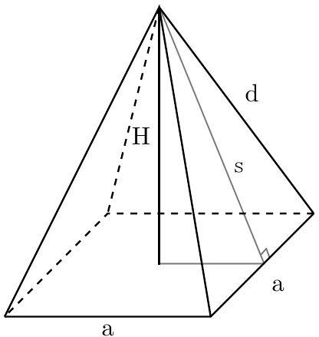
Regular-base Pyramid
- Base is a regular polygon.
- In the conventional regular-pyramid definition, the apex is above the base center.
- Lateral faces are congruent isosceles triangles.
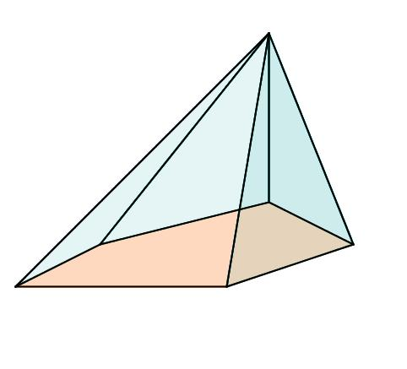
Irregular-base Pyramid
- Base is an irregular polygon.
- Base sides or angles are not all equal.
- Lateral faces need not be congruent.
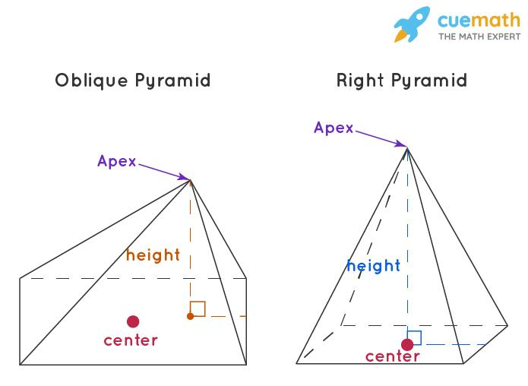
Oblique Pyramid with a Regular Base
- Base remains a regular polygon.
- Apex is offset from the base center.
- The lateral faces are generally unequal.

Applications
# Source: AI Source: Provided by: [Data Path: Persons Table -> ID Column: 1, Name_En Column: Motasem Essam] -> From: [ChatGPT] on [7/25/2026]
Regular-base pyramids are useful in:
- Architecture: Designing symmetrical pyramid roofs and decorative structures.
- Engineering: Modeling tapered components with polygonal footprints.
- Computer graphics: Creating symmetrical 3D meshes and geometric models.
- Mathematics education: Studying regular polygons, symmetry, volume, and surface area.
- Product design: Creating geometric ornaments, display objects, and polygon-based packaging.

Key Points
# Source: AI Source: Provided by: [Data Path: Persons Table -> ID Column: 1, Name_En Column: Motasem Essam] -> From: [ChatGPT] on [7/25/2026]
- A regular-base pyramid has a regular polygon as its base.
- A regular polygon has equal sides and equal interior angles.
- The base can have any number $n≥3$ of sides.
- A pyramid with an $n$-sided base has $n+1$ faces, $2n$ edges, and $n+1$ vertices.
- The volume formula is $V=\frac{1}{3}Bh$.
- For a regular right pyramid, the lateral surface area is $A_{L}=\frac{1}{2}pl$.
- A regular base does not automatically mean the pyramid is right; the apex position also matters.

Conclusion
# Source: AI Source: Provided by: [Data Path: Persons Table -> ID Column: 1, Name_En Column: Motasem Essam] -> From: [ChatGPT] on [7/25/2026]
A regular-base pyramid is a polyhedron whose base is a regular polygon. This property creates a consistent base structure and, when combined with an apex directly above the base center, produces a symmetrical regular pyramid with congruent lateral faces. Understanding the distinction between base regularity and spatial orientation is important for classifying pyramids accurately and selecting the appropriate formulas for their surface area and volume.

